PLC MODIFICATIONS REPORT

Date of issue: July, 2023

T.EN Original Supply Order: RA_00_3652 REMAN

T.EN Representative: Brice BELIN

Customer: T.EN

Equipment to be serviced: Marine Loading Arms

Location of job site: Sens, FRANCE

Loading arms PLC: Siemens CPU 412-3H Safety & Redundancy

Software: STEP7 V5.70

Latest PLC prog version: FMC_REMAN_V5_1_25-07-2023

PROGRAM TO TEST JAY CONDUCTIX ORDERS & FUNCTIONS

- Hardware modifications

  - 26/06/2023 by T.EN

PLC prog before modifications: FMC_REMAN_V4_2_04-07-2023
PLC prog after modifications: FMC_REMAN_V5_1_25-07-2023

1_-_ Add JAY CONDUCTIX Base Unit (BU) type NEMO on Profibus DP (addr. 13) like CAVOTEC.
(on same network)

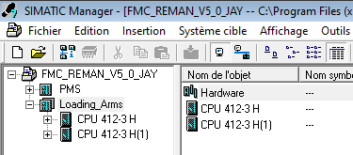

Select “Hardware” inside PLC project

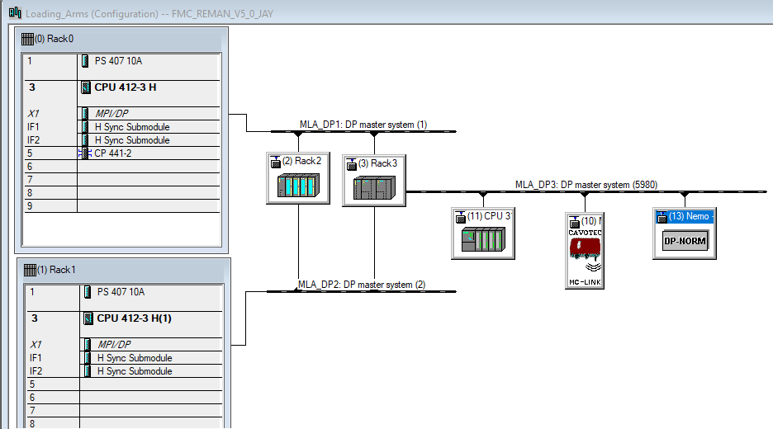
Add Jay ‘s NEMO gsd file
Nota:

here's where to find the “gsd” file in the Siemens catalog.

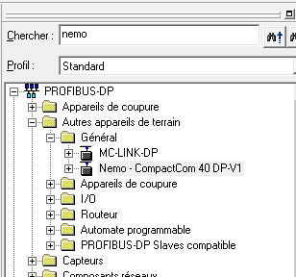

- Software modifications

  - 26/06/2023 by T.EN

PLC prog before modifications: FMC_REMAN_V4_2_04-07-2023
PLC prog after modifications: FMC_REMAN_V5_1_25-07-2023

Function: FC0 COMMON, Network 8 – Remote mode

Modification about add information about “JAY Radio Mode Selection” in parallel to “CAVOTEC”.

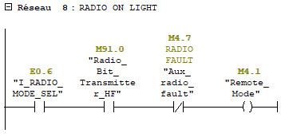
Before modification
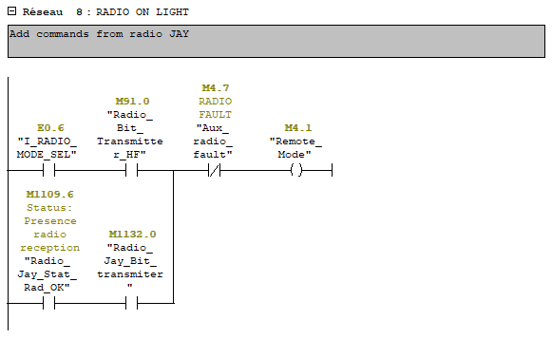
After modification

Function: FC0 COMMON, Network 11 – FMC Valid

Modification about add information about “JAY Radio F3 valid button” in parallel to “CAVOTEC”.

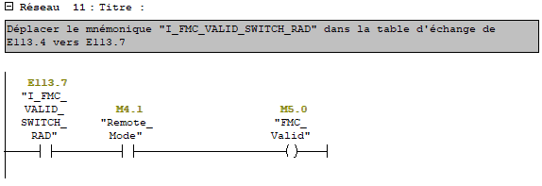
Before modification

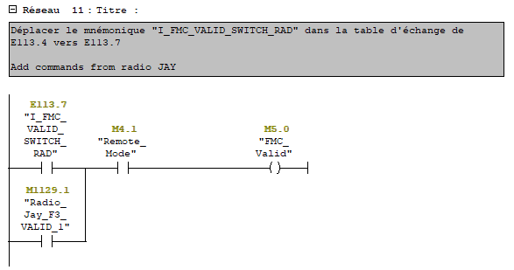
After modification

Function: FC0 COMMON, Network 15 – Stop pump

Modification about add information about “JAY Radio Stop pump order” in parallel to “CAVOTEC”.

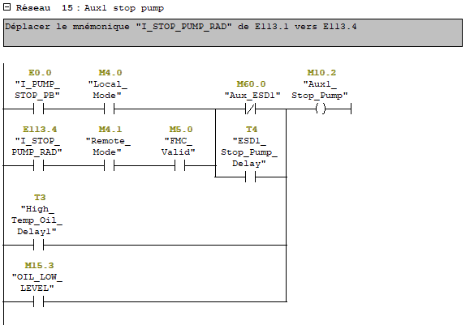
Before modification

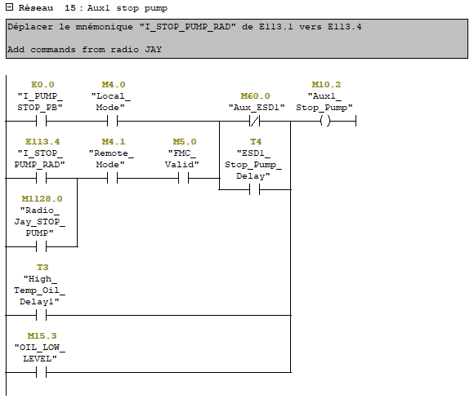
After modification

Function: FC0 COMMON, Network 18 – Start pump

Modification about add information about “JAY Radio Start pump order” in parallel to “CAVOTEC”.

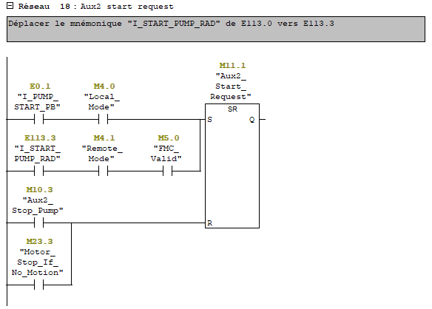
Before modification

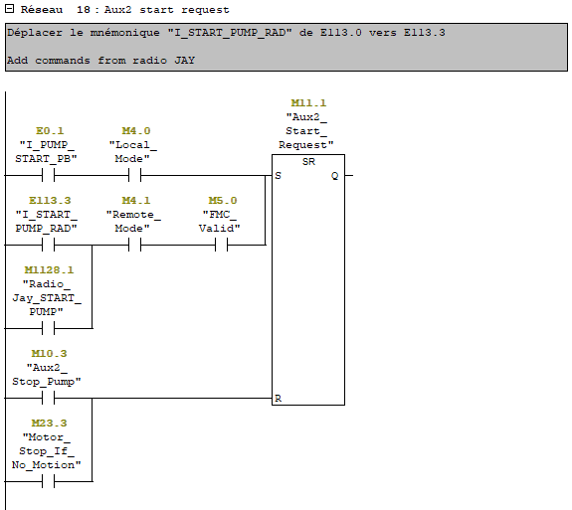
After modification

Function: FC0 COMMON, Network 43 – Inboard forward movement

Modification about add information about “JAY Radio Inboard forward order” in parallel to “CAVOTEC”.

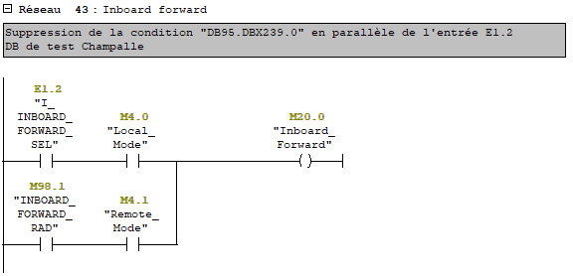
Before modification

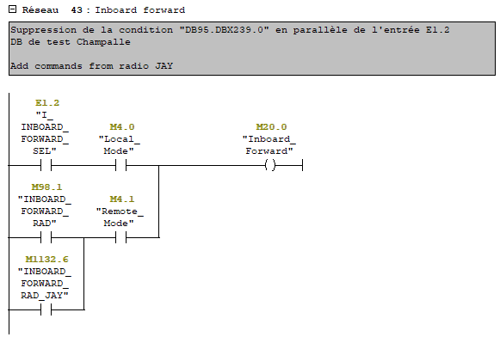
After modification
Function: FC0 COMMON, Network 44 – Inboard back movement

Modification about add information about “JAY Radio Inboard back order” in parallel to “CAVOTEC”.

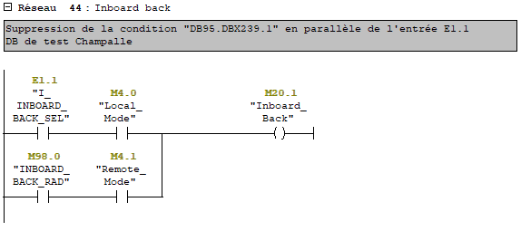
Before modification

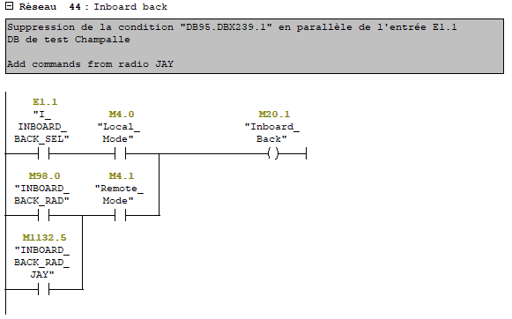
After modification
Function: FC0 COMMON, Network 45 – Outboard Out movement

Modification about add information about “JAY Radio Outboard Out order” in parallel to “CAVOTEC”.

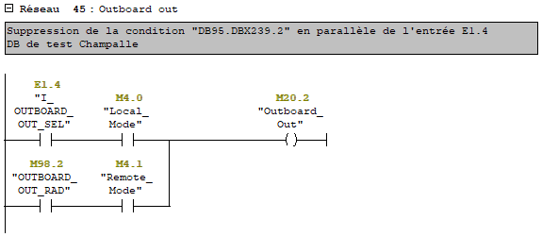
Before modification

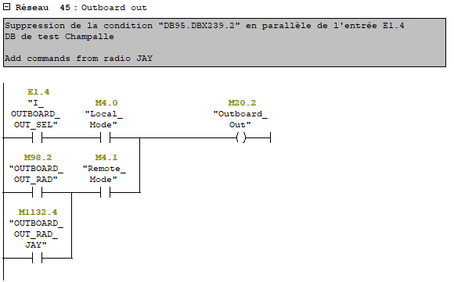
After modification
Function: FC0 COMMON, Network 46 – Outboard In movement

Modification about add information about “JAY Radio Outboard In order” in parallel to “CAVOTEC”.

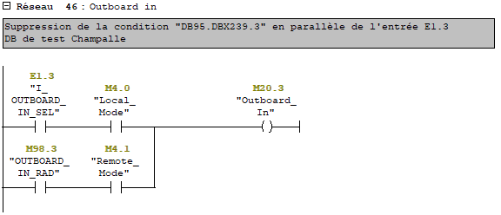
Before modification

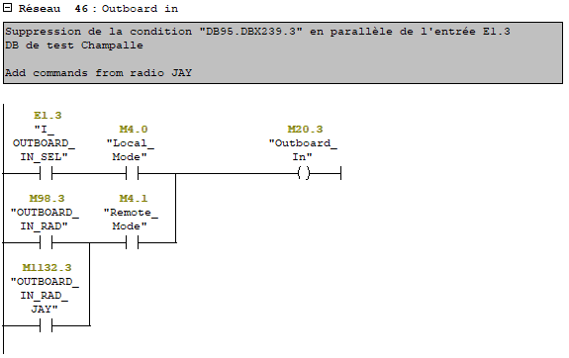
After modification

Function: FC0 COMMON, Network 47 – Slewing left movement

Modification about add information about “JAY Radio Slewing left order” in parallel to “CAVOTEC”.

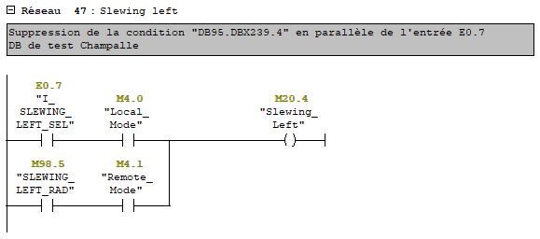
Before modification

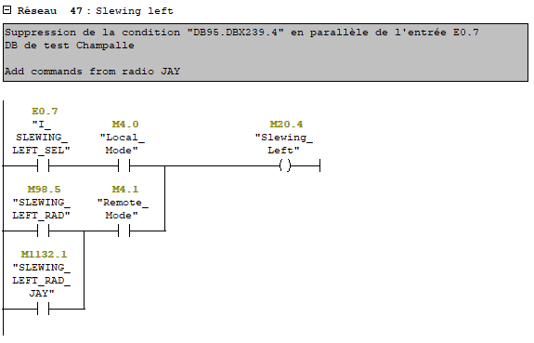
After modification
Function: FC0 COMMON, Network 48 – Slewing right movement

Modification about add information about “JAY Radio Slewing right order” in parallel to “CAVOTEC”.

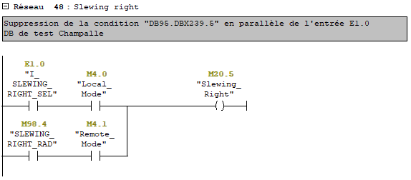
Before modification

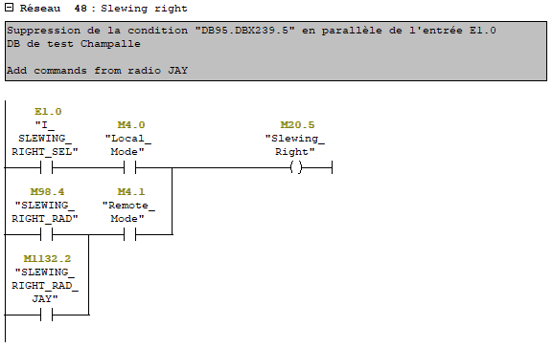
After modification
Function: FC0 COMMON, Network 54 – Arm locked

Modification about add information about “JAY Radio Arm locked order” in parallel to “CAVOTEC”.

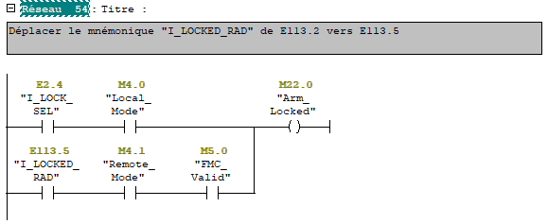
Before modification

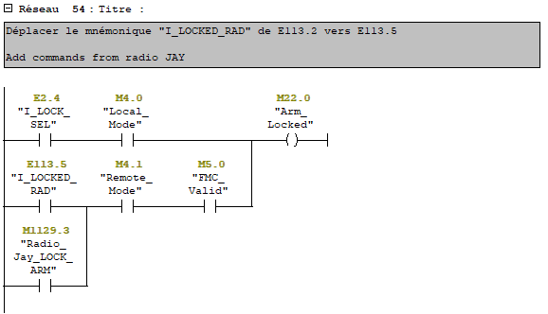
After modification
Function: FC0 COMMON, Network 55 – Arm unlocked

Modification about add information about “JAY Radio Arm unlocked order” in parallel to “CAVOTEC”.

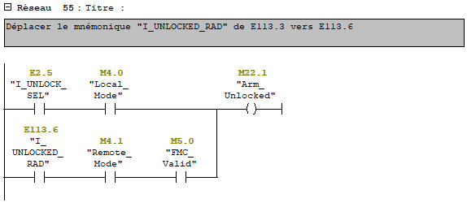
Before modification

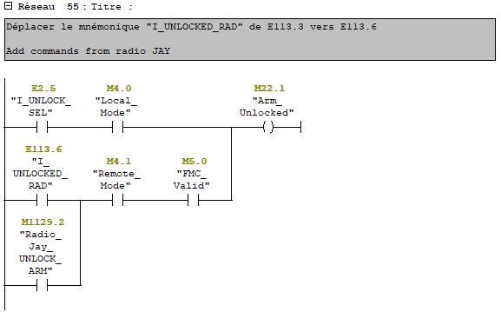
After modification
Function: FC1 ARM1, Network 1– Arm selection

Modification about add information about “JAY Radio Arm unlocked order” in parallel to “CAVOTEC”.

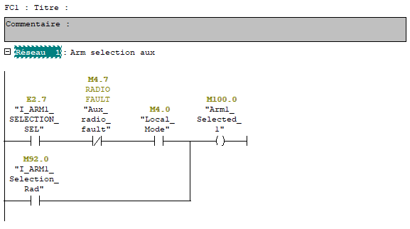
Before modification

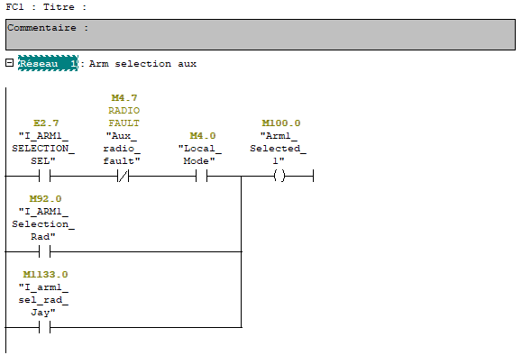
After modification

